


INDIVIDUAL ASSIGNMENT

LANKA

COMP40004

WEB DEVELOPMENT AND OPERATING SYSTEMS-1

CF22A1COM,CF22A1SE, CF22A1CS

ASSIGNMENT 2 AND 3 HAND OUT– 31ST MAR 2023
ASSIGNMENT 2 HAND IN –31ST MAY 2023
ASSIGNMENT 3 HAND IN – WEEK 18

WEIGHTAGE: ASSIGNMENT 2: 30% ASSIGNMENT 3: 30%

INSTRUCTION TO CANDIDATES:

- Students are advised to underpin their answers with the use of references (cited using the Harvard Name System of Referencing).

- Late submission will be awarded zero (0) unless Extenuating Circumstances (EC) are upheld.

- Cases of plagiarism will be penalized

- Assignment presentation should be submitted in the form of softcopy and hardcopy both; modeling work should be submitted in softcopy form

Student’s details

Name : Nisal Ulluvisheva
CB Number : CB010788
Batch Code : CFK22A1COM
Subject : Web Development and Operating System (Part 1)
Lecturer : Ms. Valuka Wijegunawardene

Acknowledgement

First and foremost, I extend my deepest thanks to the WDOS lecturer, Ms. Valuka Wijayagunawardene, for her patient guidance and enthusiastic encouragement throughout the entire assignment. Their expertise and guidance have been invaluable in shaping the direction and quality of this work.

I am also thankful to my friends and family, who have been a constant source of encouragement and motivation. Their belief in my abilities has kept me focused and determined. Their constant support has been helpful in the completion of this project.

In conclusion, I am deeply grateful to everyone who has contributed to this project. Their collective efforts and support have played a vital role in its successful completion.

31/05/2023 Nisal Ulluvisheva
(CB 010788)

Table of Contents
Student’s details 2
Acknowledgement 3
Introduction 5
Responsive Design 6
Design (Wireframe) 7
01. Home Page 7
02. Turtle Categories Page 9
03. Threats to Turtles Page 11
04. Donations Page 13
05. Hikkaduwa Turtle Hatchery Page 15
06. Kosgoda Turtle Hatchery Page 17
07. Kosgoda Turtle Hatchery Page 19
08. Local Merchandise 21
Web Hosting (GitHub) 23
Future developments 24
Conclusion 25

Introduction

This website is designed to give a wide idea of sea turtles, turtle nesting, threats to sea turtles, and what we can do to protect them. Through this website, we hope to protect endangered sea turtle species and strengthen the turtle conservation fund through donations. So, users can get a wide idea of these amazing sea creatures, and they can help strengthen turtle funds by donating money and purchasing various local merchandise.
The entire website consists of eight web pages. Six web pages are directly linked to the navigation bar. Two webpages are linked to "Other Turtle Hatchery" button and one web page is linked to Section 2 in "Donations" page. You can get an idea of page linking from the chart below.
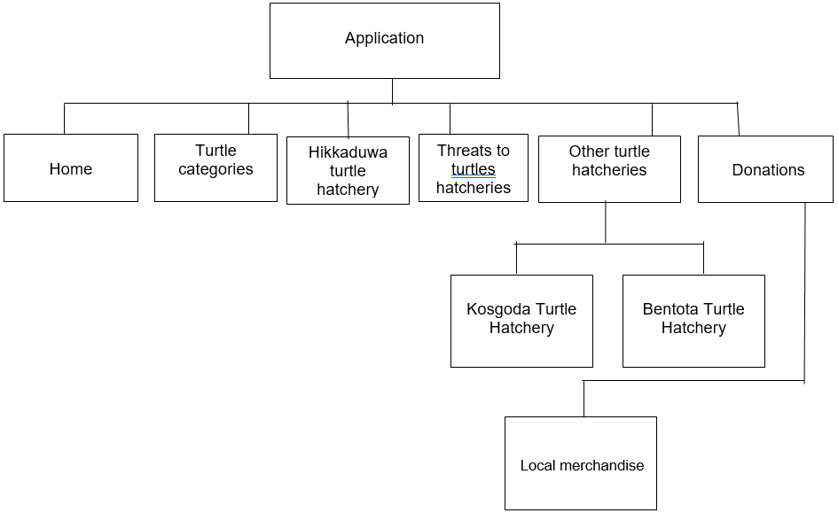

Responsive Design

The pixel size of the screen varies from brand to brand. Therefore, this website is designed to be responsive on all mobile phones with an average pixel size. So, this website is responsive for 380–414 pixels. Users can get the best responsive experience with the 414 x 636 screen resolution on every mobile phone.
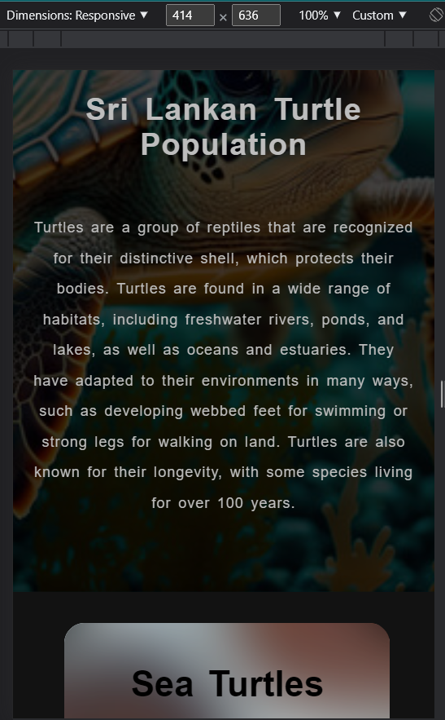

Design (Wireframe)

Home Page

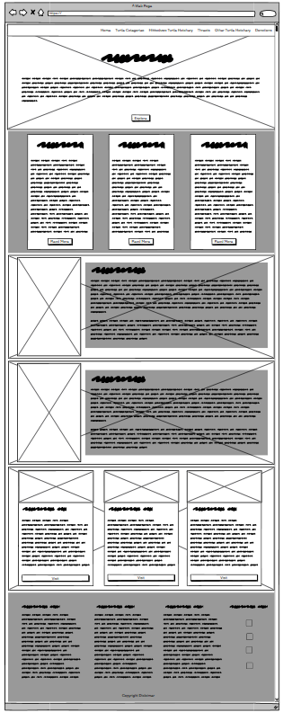
Desktop View
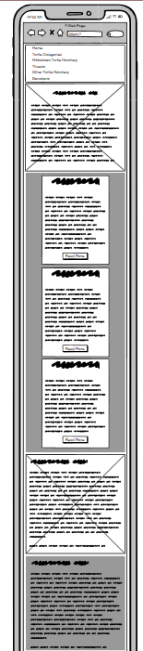
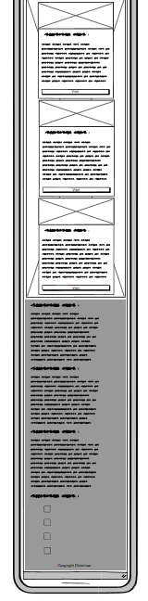
Mobile
View

Turtle Categories Page
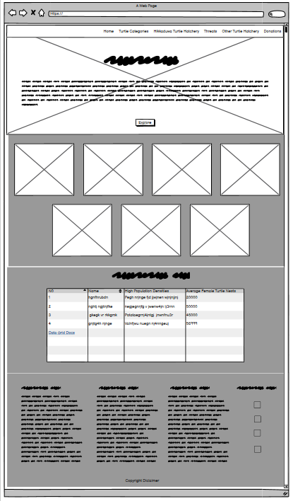
Desktop View

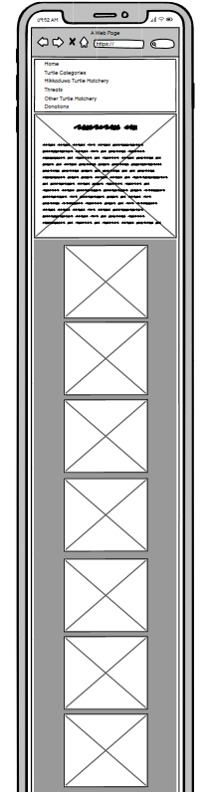
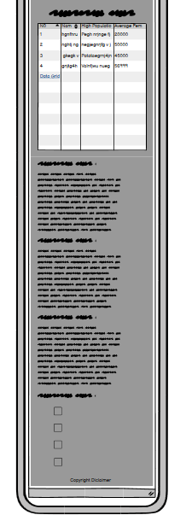
Mobile
View

Threats to Turtles Page

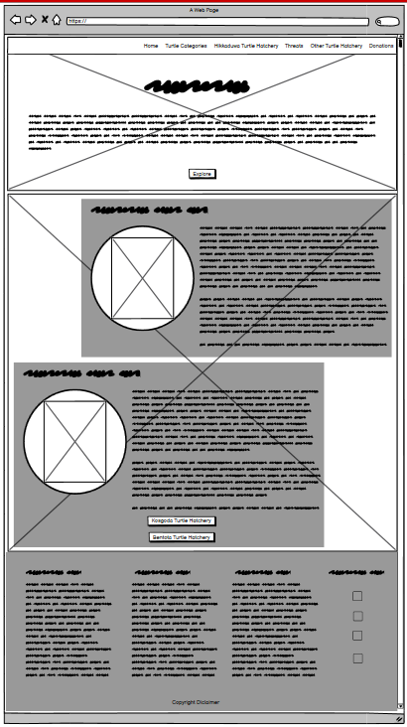
Desktop View

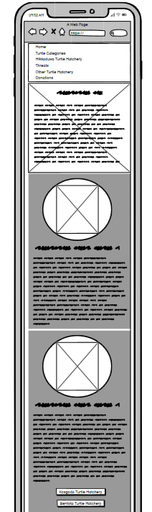
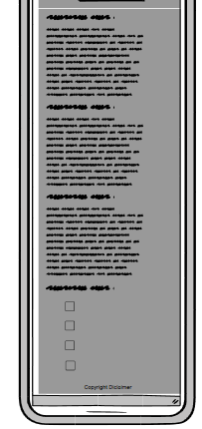
Mobile
View

Donations Page

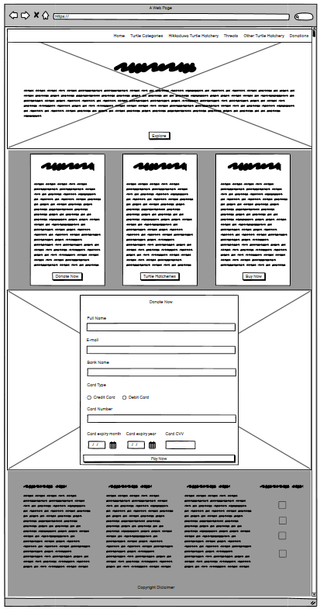
Desktop View

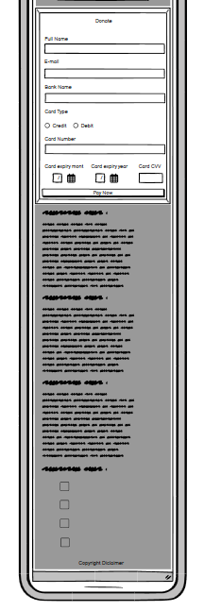
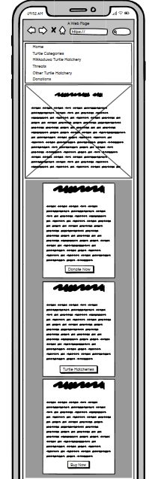
Mobile
View

Hikkaduwa Turtle Hatchery Page

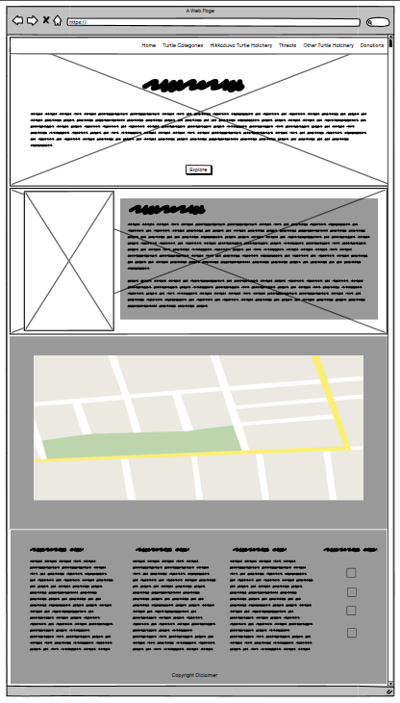
Desktop View
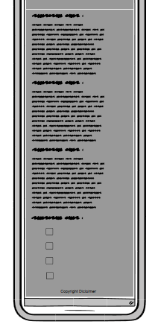
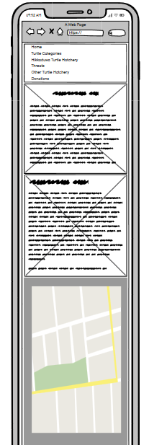
Mobile
View

Kosgoda Turtle Hatchery Page

Desktop View
Mobile
View

Kosgoda Turtle Hatchery Page

Desktop View

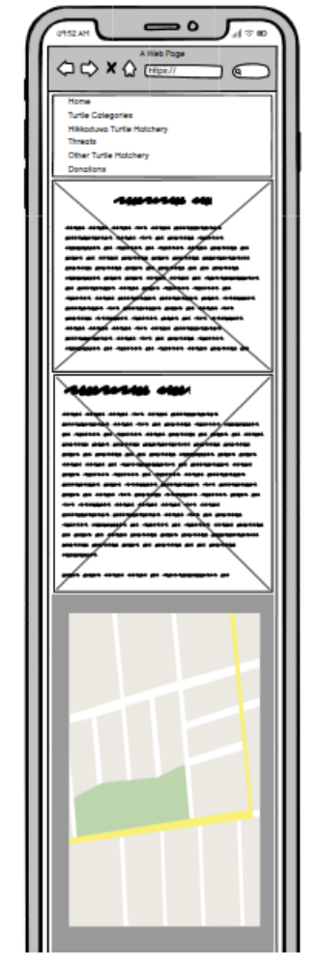
Mobile
View

Local Merchandise

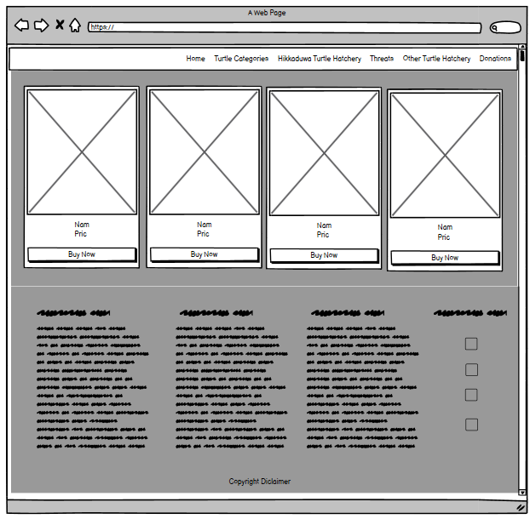
Desktop View

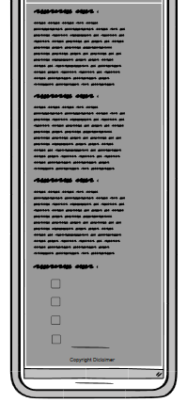
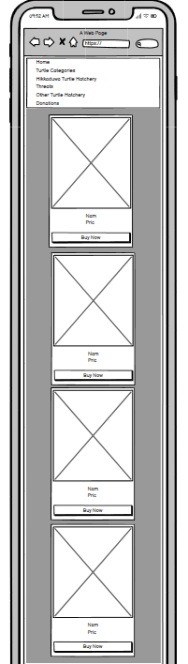
Mobile
View

Web Hosting (GitHub)

This website is hosted on the Github.io platform. So, users can open the website in any browser via this link.

Link - https://ninzey.github.io/NisXul005.github.io/Home.html

Future developments

We hope to continue the development of this website. And our target is to deliver this message in a very convenient way to society and help protect sea turtles. Therefore, we hope to do the following :

- First of all, we hope to expand our payment methods. Therefore, local and foreign people can make their payments easily by using their mobile phones.
- As well, we hope to expand our local merchandise store, add more handmade items, and sell them through the best online selling platforms all over the world.
- We hope to advertise the turtle hatcheries on social media. Therefore, we can attract more tourists to our turtle hatcheries.
- We hope to responsively design the website for tablets, home pods, and many more screen sizes too. So, users can easily access the website from any device.

Conclusion

By implementing effective conservation measures and raising awareness about the importance of sea turtle conservation, we can strive to ensure the long-term survival and well-being of these vulnerable marine species. So, the final result of all these things is to protect these amazing and endangered sea creatures.

